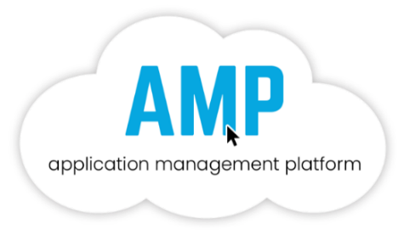

TESTING MANUAL

Introduction
Welcome to the Wireless Tower Solution’s AMP Testing Manual. Wireless Tower Solutions is an essential intermediary between local governments (its clients) and wireless facilities owners, primarily responsible for obtaining permits for wireless tower modifications and installations. We offer our clients an Application Management Platform (AMP) to streamline this process, enabling wireless facility owners to SUBMIT their applications easily.

This training manual aims to shed light on the pivotal role of software testing within our organization. Our primary goal is to ensure the ﬂawless operation of our AMP. Software testers like yourself play a crucial role in identifying and resolving any potential errors or glitches within the application, guaranteeing that our clients can complete their application forms without interruption.

As a software tester at Wireless Tower Solutions, your mission is to maintain an AMP form free from errors and bugs. We understand the importance of providing a seamless process for our users. Our testing procedures focus on eliminating any obstacles or inconveniences that might arise while completing these forms. By achieving this, we empower our clients to navigate the permitting process and contribute to their success smoothly.

This manual will provide a comprehensive guide to software testing, including best practices, methodologies, and speciﬁc procedures relevant to your role as a software tester. By following the guidelines outlined in this manual, you will help us ensure that our AMP remains a reliable and eﬃcient tool for our clients and continues to support our mission. Your dedication to quality assurance and meticulous attention to detail are invaluable components of Wireless Tower Solutions’ ongoing success. Together, we can maintain the integrity and eﬀectiveness of our AMP.

Roles and Responsibilities: Software Tester
In the position of Software Tester, you are a vital part of the quality assurance process within Wireless Tower Solutions. Reporting directly to President Mel Patterson or another designated employee and working in close collaboration with Lead Software Engineers or Developers, your primary objective is to ensure that the Application Management Platform (AMP) and its forms provided by Wireless Tower Solutions are free from errors and bugs, ensuring a seamless process for granting permits for 5G towers.

Your key responsibilities include test planning, which involves creating comprehensive test plans outlining the scope, approach, resources, and schedule for all testing activities. You’ll also be responsible for thoroughly testing the AMP forms, focusing on identifying and documenting potential errors and bugs. Eﬀective communication is paramount in this role; you must report any issues during training to facilitate swift resolution and maintain clear and productive communication with coworkers. You’ll also keep meticulous records of test cases, results, and other relevant documents. Always expect high professionalism in your work, and you’ll need to consistently demonstrate a commitment to Wireless Tower Solutions’ mission and quality standards. Your role is crucial in maintaining quality assurance by ensuring that the AMPs meet the required quality and functionality standards to support reviewing wireless tower applications.

Purpose:
Conduct software testing on the Wireless Tower Solutions DEMO website. This AMP form is a critical bridge between local governments and wireless facilities including small wireless facilities, facilitating the acquisition of permits for installing modiﬁcation or relocation of 5G wireless towers. This software testing process ensures that the AMP functions seamlessly, providing a streamlined experience for wireless facility applicants.
Eligibility Facility Colocation
New Wireless Facility

Tower Wireless Facility

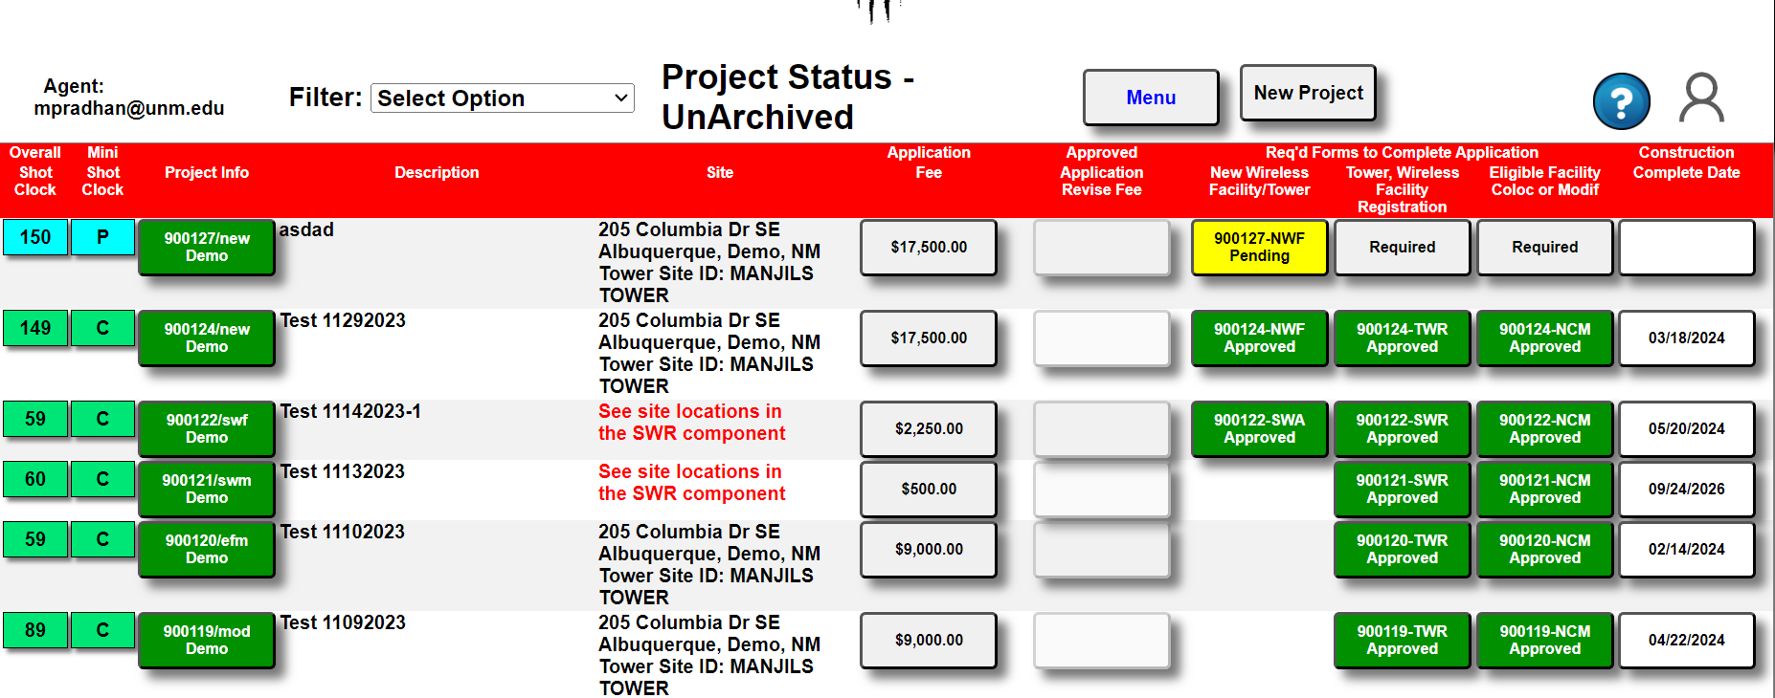
Project Information

Components (Traditional Towers):
Project Information: This component collects essential project details, including Project Carrier Name, Applicant’s Project Name, Project Number, Applicant’s Project Manager, Agent’s Company Name, Support Structure type, Company’s Project Manager, Project Type, and Project description.

New Tower/Wireless Facility: In this section, applicants justify their application, upload documents explaining the justiﬁcation, and provide the required PDF documents that describe eﬀorts to utilize existing structures per the ordinance.

Tower, Wireless Facility: This component oﬀers information about the property where the tower will be installed, including ownership details, leasing status, tower type, and other data.

New Wireless Facility/Colocation/Modiﬁcation: This component serves as an application form, collecting crucial information about 5G tower projects. Information includes structural analysis engineer details, insurance information, and the installation’s projected start and completion dates or modiﬁcation.

Components (Small Wireless Facility):
New SWF Land Use Authorization: The New SWF Land Use Authorization component is crucial to the Small Wireless Facility (SWF) application process. SWF applicants utilize this section to provide vital information regarding access to rights-of-way, pole attachment, and pole replacement agreements. This data is essential for obtaining authorization for deploying SWF infrastructure during 5G buildouts, ensuring compliance with regulatory requirements.

New Small Wireless Facility Registration: In the New Small Wireless Facility Registration component, SWF applicants SUBMIT comprehensive details about the sites where they intend to install, colocate, or modify 5G towers. The provided application form collects essential information, including site names, unique identification details, locations, tower types, tower heights, and other relevant site-specific specifications. Accurate completion of this component is crucial for efficient evaluation and regulatory compliance during the deployment of SWF facilities.
New Wireless Facility/Colocation/Modiﬁcation: This component contains an application form similar to traditional tower installation.

Testing Focus:
Software testing focuses on these components to verify functionality, data input validation, and user experience. It aims to identify and resolve any errors, glitches, or discrepancies in the application form to ensure a seamless and error-free user journey. By conducting rigorous testing on the Wireless Tower Solutions website, we strive to deliver a reliable, eﬃcient, and user-friendly form for wireless facilities seeking permits for their wireless tower installations.

Testing Environment:
As a software tester for Wireless Tower Solutions, you will primarily work within the AMP provided by the company. The testing environment consists of two primary user roles: Agent and SuperAdmin. You must test the application process from Agent and SuperAdmin perspectives, covering both Big and Small Wireless Facilities. You will also be required to use two-factor authentication for secure login.

Testing Procedures for Traditional Towers:
- Agent Role Testing:
  - Start by logging into your Agent’s account.
  - Check that you receive the two-factor authentication code.
  - Ensure that the login process is successful.
  - Select the appropriate Demo site for testing.
  - Create a new project and ﬁll the Project Information component, including text ﬁelds, section options, and confirm that the text box can handle special characters.
  - Additionally, test the addition of a new carrier.
  - Also, test the addition of a new tower.
  - Verify that buttons, such as save, work as expected.
  - Conﬁrm that the save process to ensure information is modified and saved for future use after pressing SAVE button.
  - Test the submission process by clicking the SUBMIT button, which sends the application to SuperAdmin for review.

SuperAdmin Role Testing:
  - Log in to your SuperAdmin account using the same login process as the Agent.
  - Access the same site as the Agent for approval.
  - Review the information submitted by the Agent, including special characters converted to underscores after pressing SAVE button.
  - Check or uncheck ﬁelds for revision as necessary.
  - Approve or send the project back for revision.
  - When sending for revision, input additional comments or instructions in the pop-up.
  - Ensure that the SuperAdmin’s login process is successful and authenticates to the Agent’s.
  - Verify that the component color changes based on the project’s status (e.g., cyan, yellow, red, green).
  - Test the functionality of the Shot Clock, ensuring it decreases by one day if the project is not approved or sent back for revision by SuperAdmin.

Additional Component Testing:
  - Test the remaining three components (New Wireless Facility, Tower Facility Registration, and New Wireless Eligible Facility/Colocation/Modiﬁcation).
  - Follow the same testing procedures used for the Project Information component.
  - Ensure that the Agent can ﬁll out the forms without encountering issues.
  - Conﬁrm that the Agent can access, edit, and re-submit these components only after SuperAdmin requests a REVISE of the Project Information or other components.

Testing Procedures for Small Wireless Facilities:

The testing process for the Small Wireless Facility application within the broader Wireless Tower Solutions platform involves specific considerations due to its unique requirements. Small Wireless Facilities are comparable to their larger counterparts and follow a slightly different application process. This section of the testing manual delves into the distinct elements that Software Testers must know when assessing the Small Wireless Facility application. While the core structure of the online application remains the same, some specific components and parameters are tailored to accommodate the needs of Small Wireless Facility applications. Understanding these differences and nuances is crucial to ensure a comprehensive and precise testing process.

- Agent Role Testing:
  - Start by logging into the Agent’s account.
  - Check that you receive the two-factor authentication code.
  - Ensure that the login process is successful.
  - Select the appropriate site for testing.
  - Create a new project, select Small Wireless Facility in the Project Type option, and fill in the Project Information component, including text ﬁelds and section options and also confirm that the text box can handle special characters.
  - Additionally, test the addition of a new carrier.
  - Test the selected project type (e.g., "Modification") to ensure it functions correctly.
  - Verify that buttons like SAVE, SUBMIT, and BACK buttons work as expected.
  - Conﬁrm that the save process to ensure information is modified and saved for future use after pressing SAVE button.
  - Test the submission process by clicking the SUBMIT button, which sends the application to SuperAdmin for approval.

SuperAdmin Role Testing:
  - Log in to the SuperAdmin account using the same login process as the Agent.
  - Access the same site as the Agent for approval.
  - Review the information submitted by the Agent, including special characters converted to underscores after pressing SAVE button.
  - Check or uncheck ﬁelds for revision as necessary.
  - Approve or send the project back for revision.
  - When sending for revision, input additional comments or instructions in a pop-up.
  - Ensure that the SuperAdmin’s login process is successful and authenticates to the Agent’s.
  - Verify that the component color changes based on the project’s status (e.g., cyan, yellow, red, green).
  - Test the functionality of the Shot Clock, ensuring it decreases by one day if the project is not approved or sent back for revision by SuperAdmin.

Additional Component Testing:
  - Test the remaining three components (New Wireless Facility, Tower Facility Registration, and New Wireless Eligible Facility/Colocation/Modiﬁcation).
  - Follow the same testing procedures used for the Project Information component.
  - Ensure that the Agent can ﬁll out the forms without encountering issues.
  - Conﬁrm that the Agent can access and complete these components only after SuperAdmin approves the Project Information component.

Specific Field-Testing Guidelines
As part of our rigorous software testing process, it is crucial to test various types of input fields and controls present in the Application Management Platform (AMP). Each field type requires specific testing methods to ensure they function correctly and handle data accurately. Below are the guidelines for testing key field types:

- TextField Testing
  - General Input: Ensure that the text field accepts alphanumeric characters and adheres to any specified character limits.
  - Special Characters: Test the acceptance or rejection of special characters based on field requirements.
  - Empty Field Validation: Check the application's response when the text field is left empty, if applicable.
- Drop Down Menu Testing
  - Option Selection: Verify that all options are selectable and correctly displayed.
  - Default Value: Confirm if a default value is set and whether it is appropriate.
  - Dynamic Behavior: Test any dynamic changes in the form based on selected options (if applicable).
- Numeric TextField Testing
  - Number Input: Ensure that the field only accepts numerical input and rejects alphabetic and special characters.
  - Range Validation: Test for the acceptance of numbers within a specified range, if applicable.
  - Decimal Handling: Check how the field handles decimal values if required.
- File Uploader Button Testing
  - File Selection: Confirm the ability to browse and select files.
  - File Type Restriction: Verify that only allowed file types (e.g., PDF, DOCX) can be uploaded.
  - Size Limitation: Test the maximum file size restrictions, if any.

- Date Picker Testing
  - Date Selection: Ensure smooth selection of dates from the calendar interface.
  - Format Validation: Verify that the selected date matches the required format (e.g., MM/DD/YYYY).
  - Range Restrictions: Test any restrictions on date ranges, such as past or future date limitations.
- Checkbox and Radio Button Testing
  - Selection and Deselection: Confirm that checkboxes and radio buttons can be selected and deselected as required.
  - Default State: Check if any default selection exists and whether it aligns with the form's requirements.
  - Dependent Field Activation: Test if selecting these options enables or disables other form components appropriately.
- Submit and Cancel Button Testing
  - Functionality: Verify that the submit button sends data correctly and the cancel button clears or exits the form as intended.
  - Disabled State: Test conditions under which these buttons are disabled or enabled.

General Testing Notes
- Consistency: Ensure uniformity in the behavior of similar field types across different form components.
- Error Messaging: Check for clear and relevant error messages for invalid inputs or field validations.
- Usability: Evaluate the ease of navigating and interacting with each field type.

By meticulously testing each field type, we ensure the reliability and user-friendliness of our AMP. This detailed approach helps in uncovering potential issues that might hinder the application process, thereby enhancing the overall effectiveness of the platform.

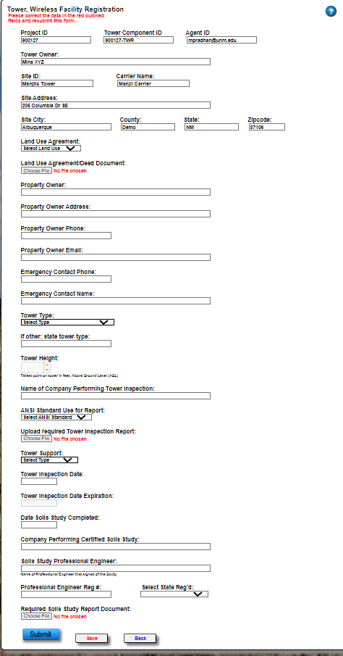
Text Field with Buttons
File Uploader Button
Date Text Field
Buttons
Numeric Text Field
Text Field
Drop Down Menu

Bugs and Issue Reporting:
As a software tester for Wireless Tower Solutions, you will use ThreadTrac, a web application designed for reporting discrepancies, bugs, and issues. This tool will serve as a central platform for eﬃcient communication between you, Lead Software Developers, engineers, and other relevant stakeholders.
Here’s the process for reporting bugs and issues:

Identify the Issue:
  - Take note of any discrepancies, errors, or unexpected behavior within the AMP during your testing procedures.

Access ThreadTrac:
  - To identify an issue, log in to ThreadTrac, a dedicated web application designed for issue reporting.

SUBMIT a New Report:
  - Inside ThreadTrac, create a new post to report by selecting the Demo Testing option in the Group pull down menu.

Provide Detailed Information:
  - In your report, describe your problem, including what you did when the issue occurred and any error messages you received.

Attach Evidence:
  - Attach supporting evidence, such as screenshots, any other evidence (such as a copy of the URL address where the problem occurred), or any ﬁles related to the issue. These visual aids can help in understanding and resolving the problem.

Assign to Paul Dubinsky:
  - Assign the bug or issue report to the Lead Software Engineer Developer or Engineer, ensuring he knows the problem and can prioritize the resolution.

Track Progress:
  - Monitor the progress of the issue within ThreadTrac. You can receive updates, clariﬁcations, or resolutions from Paul as he works on the reported problems.

Veriﬁcation and Closure:
  - Once Paul addresses and resolves the issue, verify the ﬁx. If the problem is fixed, you can close the report within ThreadTrac.

Documentation:
  - Ensure that all bugs and issues, along with their resolutions, are thoroughly documented within ThreadTrac. This documentation helps maintain a record of the application’s reliability and provides insights for further improvements.

By adhering to this process, you can eﬃciently report and address any issues you encounter during your testing. ThreadTrac helps streamline communication and ensures a systematic approach to issue resolution.

